SAA-CO2

Practice Test-4

Marked

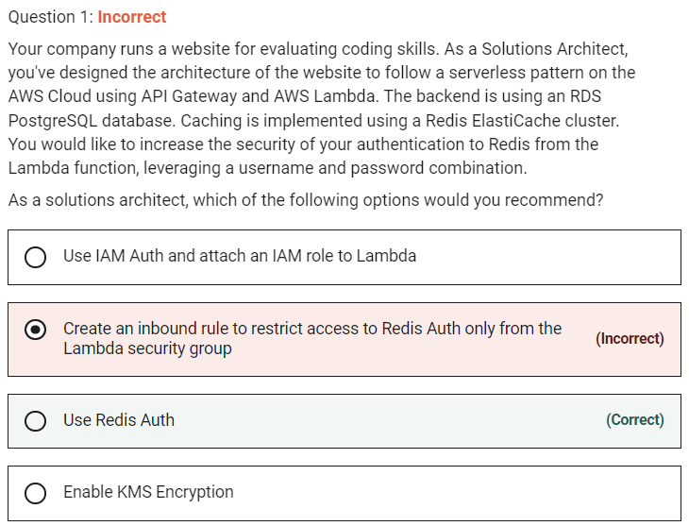

 IAM Auth is not supported by ElastiCache.

Marked

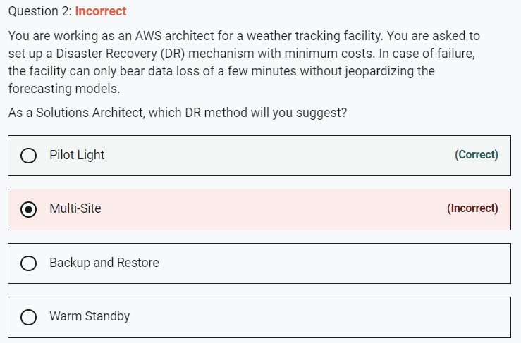

For backup and restore, it takes hours to restore

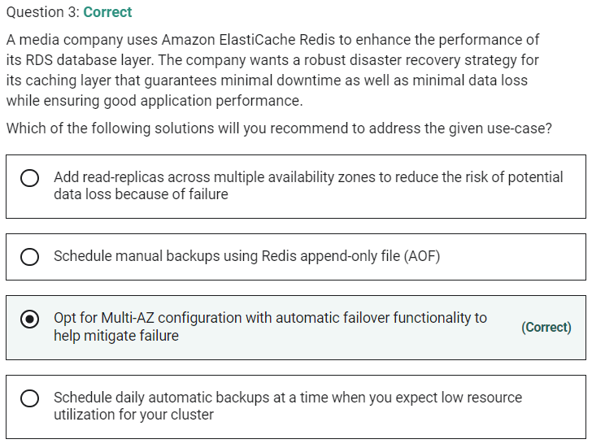

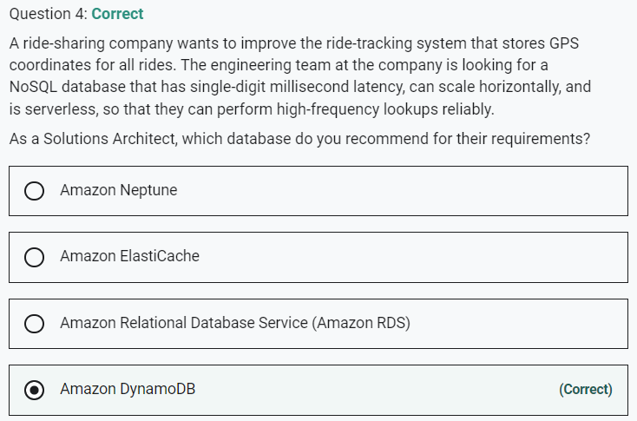

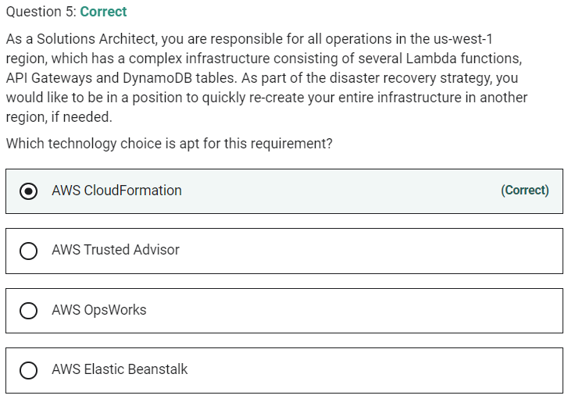

**Marked**

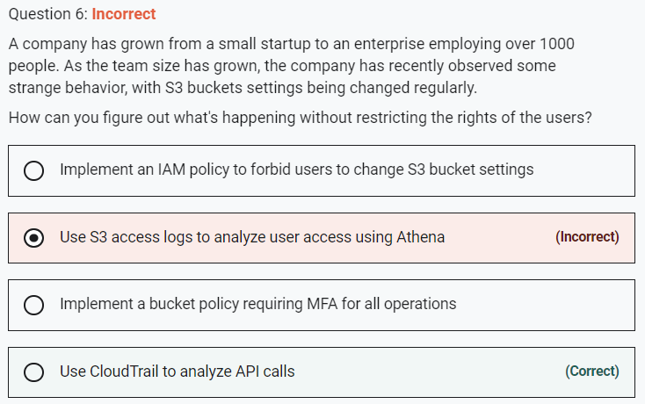

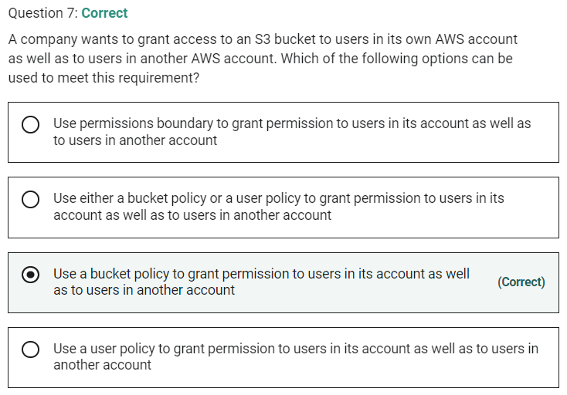

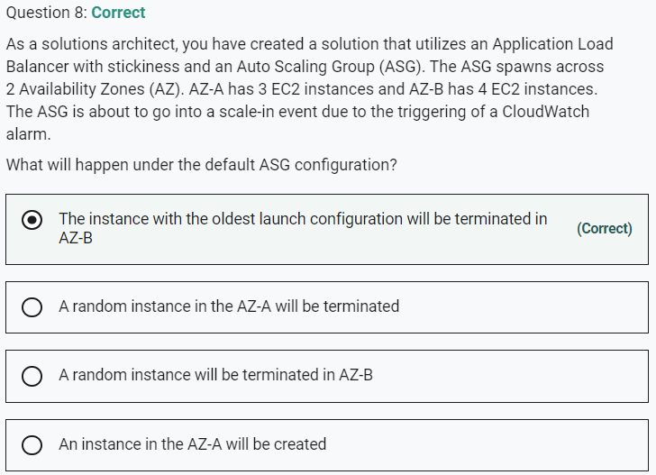

Marked

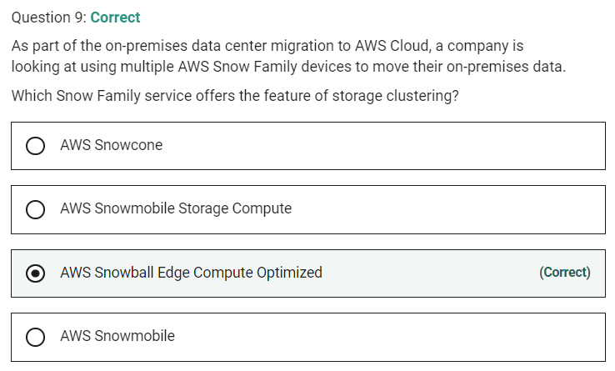

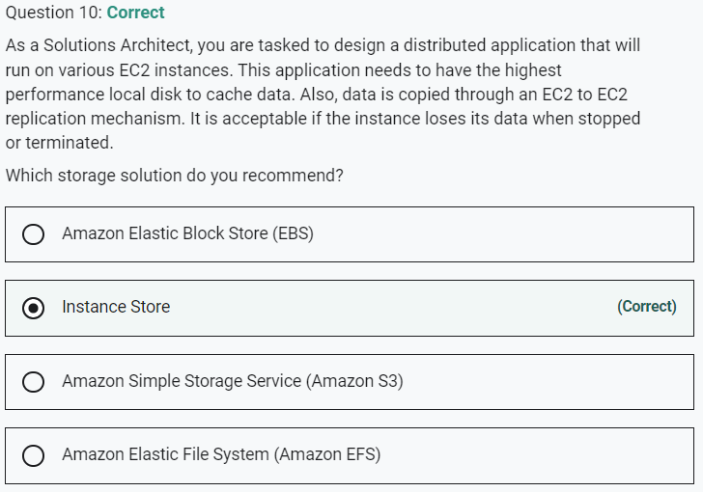

Marked

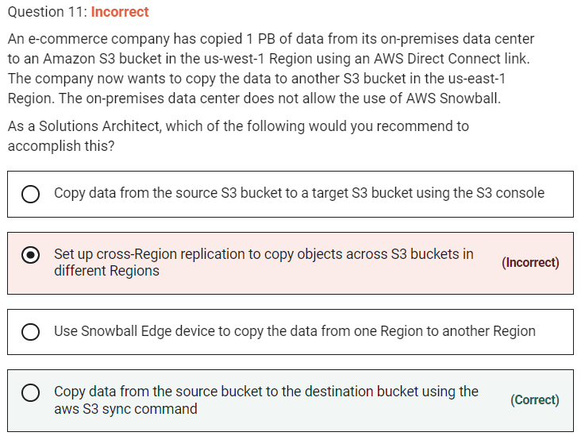

Since there is large size data we cannot use console.

**Copy data from the source bucket to the destination bucket using the aws S3 sync command**

The aws S3 sync command uses the CopyObject APIs to copy objects between S3 buckets. The sync command lists the source and target buckets to identify objects that are in the source bucket but that aren't in the target bucket.

You can use the command like so:

aws s3 sync s3://DOC-EXAMPLE-BUCKET-SOURCE s3://DOC-EXAMPLE-BUCKET-TARGET

**Set up cross-Region replication to copy objects across S3 buckets in different Regions** - As the data already exists in the source bucket, so you cannot use cross-Region replication because, by default, replication only supports copying new Amazon S3 objects after it is enabled.

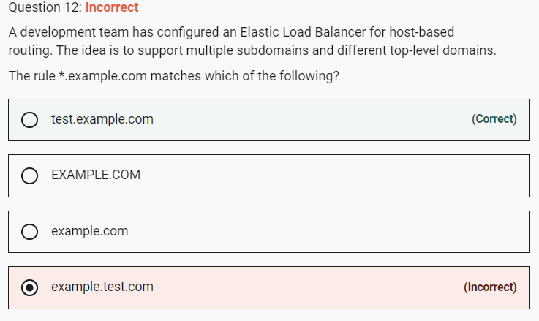

Marked

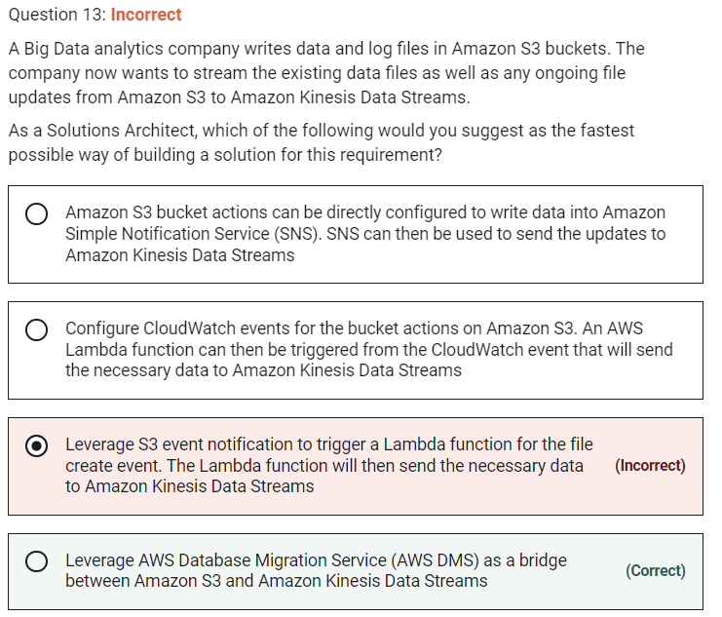

**Leverage AWS Database Migration Service (AWS DMS) as a bridge between Amazon S3 and Amazon Kinesis Data Streams** - You can achieve this by using AWS Database Migration Service (AWS DMS). AWS DMS enables you to seamlessly migrate data from supported sources to relational databases, data warehouses, streaming platforms, and other data stores in AWS cloud.

The given requirement needs the functionality to be implemented in the least possible time. You can use AWS DMS for such data-processing requirements. AWS DMS lets you expand the existing application to stream data from Amazon S3 into Amazon Kinesis Data Streams for real-time analytics without writing and maintaining new code.

**Leverage S3 event notification to trigger a Lambda function for the file create event. The Lambda function will then send the necessary data to Amazon Kinesis Data Streams** - Using Lambda functions would require significant custom development to write the data into Kinesis Data Streams, so this option is not the right fit.

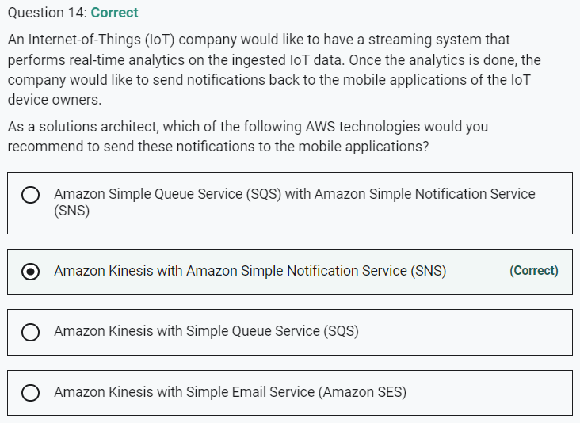

Marked

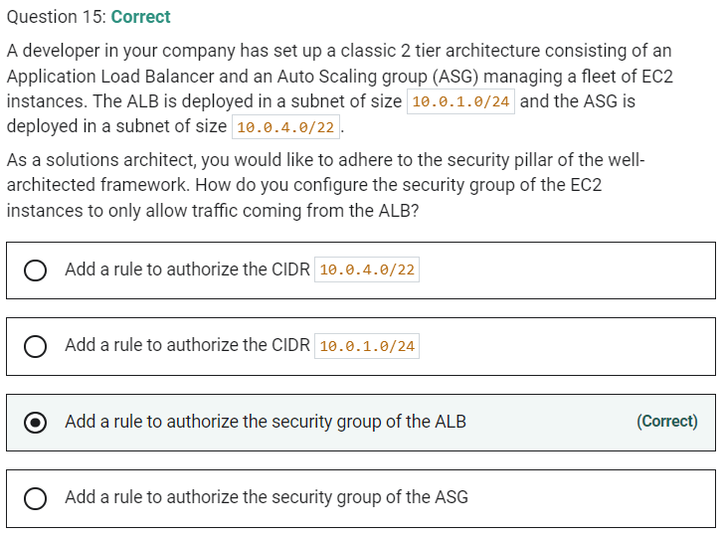

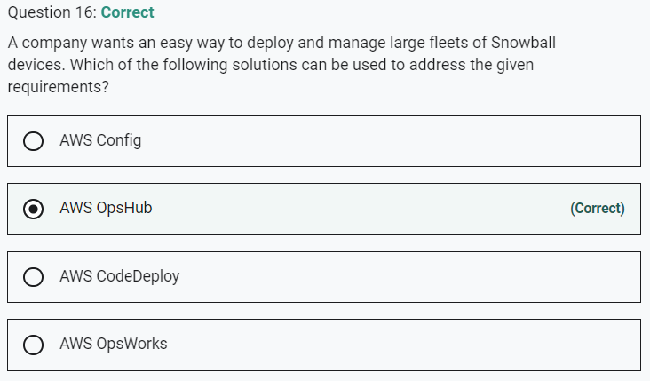

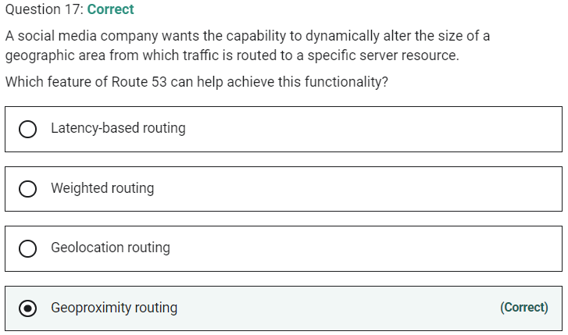

Marked

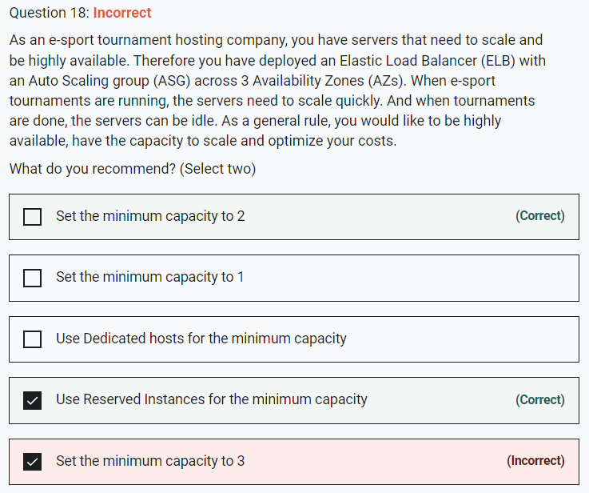

**Set the minimum capacity to 2**

You configure the size of your Auto Scaling group by setting the minimum, maximum, and desired capacity. The minimum and maximum capacity are required to create an Auto Scaling group, while the desired capacity is optional. If you do not define your desired capacity upfront, it defaults to your minimum capacity.

Here, even though our ASG is deployed across 3 AZs, the minimum capacity to be highly available is 2. When we specify 2 as the minimum capacity, the ASG would create these 2 instances in separate AZs. If demand goes up, the ASG would spin up a new instance in the third AZ. Later as the demand subsides, the ASG would scale-in and the instance count would be back to 2.

**Use Reserved Instances for the minimum capacity**

Reserved Instances provide you with significant savings on your Amazon EC2 costs compared to On-Demand Instance pricing. Reserved Instances are not physical instances, but rather a billing discount applied to the use of On-Demand Instances in your account. These On-Demand Instances must match certain attributes, such as instance type and Region, to benefit from the billing discount. Since minimum capacity will always be maintained, it is cost-effective to choose reserved instances than any other option.

In case of an AZ outage, the instance in that AZ would go down however the other instance would still be available. The ASG would provision the replacement instance in the third AZ to keep the minimum count to 2.

Marked

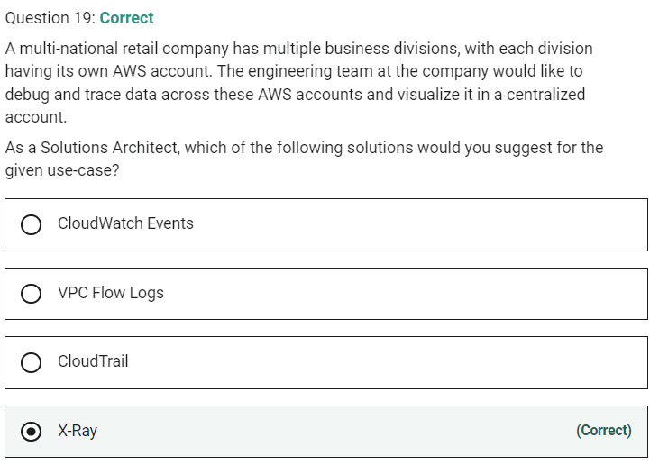

AWS X-Ray helps developers analyze and debug production, distributed applications, such as those built using a microservices architecture. With X-Ray, you can understand how your application and its underlying services are performing to identify and troubleshoot the root cause of performance issues and errors. X-Ray provides an end-to-end view of requests as they travel through your application and shows a map of your application’s underlying components.

You can use X-Ray to collect data across AWS Accounts.

**Marked**

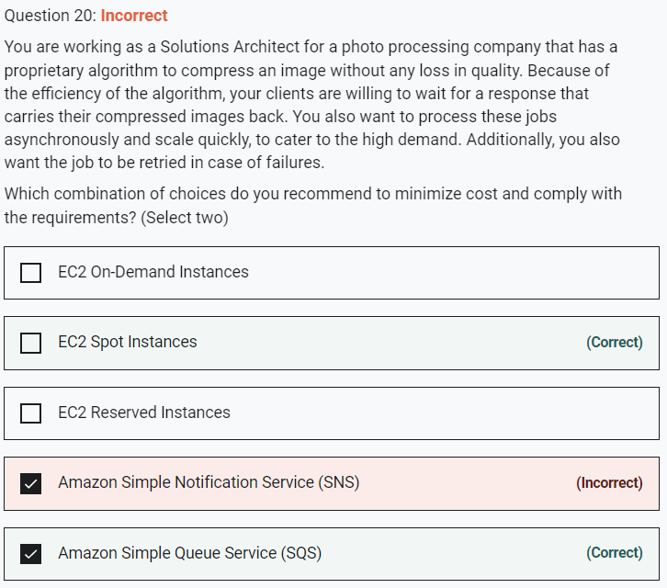

Marked

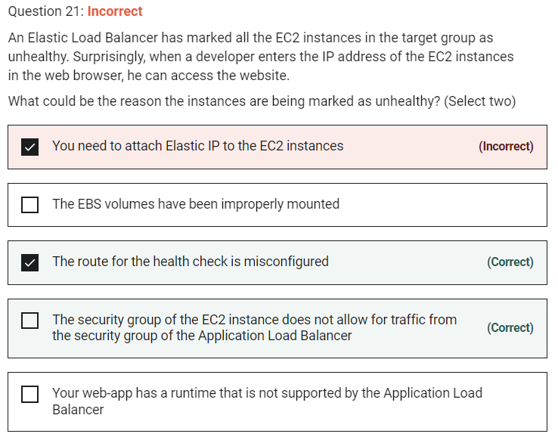

**The EBS volumes have been improperly mounted** - You can access the website using the IP address which means there is no issue with the EBS volumes. So this option is not correct.

**Your web-app has a runtime that is not supported by the Application Load Balancer** - There is no connection between a web app runtime and the application load balancer. This option has been added as a distractor.

**You need to attach Elastic IP to the EC2 instances** - This option is a distractor as Elastic IPs do not need to be assigned to EC2 instances while using an Application Load Balancer.

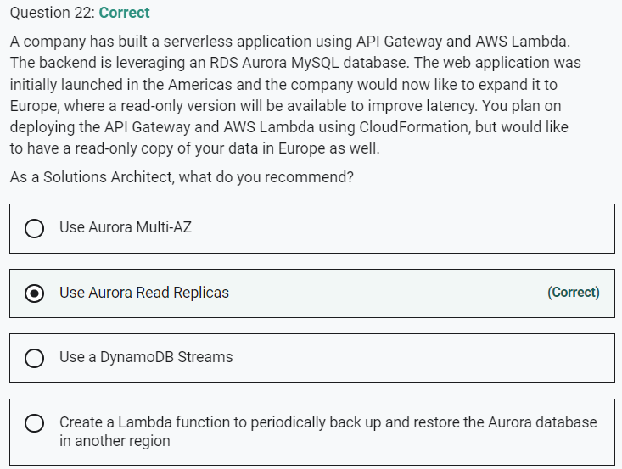

Marked

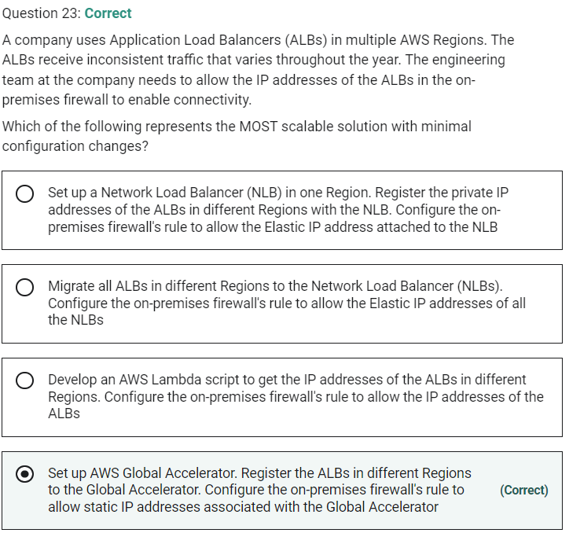

**Set up AWS Global Accelerator. Register the ALBs in different Regions to the Global Accelerator. Configure the on-premises firewall's rule to allow static IP addresses associated with the Global Accelerator** - AWS Global Accelerator is a networking service that helps you improve the availability and performance of the applications that you offer to your global users. AWS Global Accelerator is easy to set up, configure, and manage. It provides static IP addresses that provide a fixed entry point to your applications and eliminate the complexity of managing specific IP addresses for different AWS Regions and Availability Zones.

Associate the static IP addresses provided by AWS Global Accelerator to regional AWS resources or endpoints, such as Network Load Balancers, Application Load Balancers, EC2 Instances, and Elastic IP addresses. The IP addresses are anycast from AWS edge locations so they provide onboarding to the AWS global network close to your users.

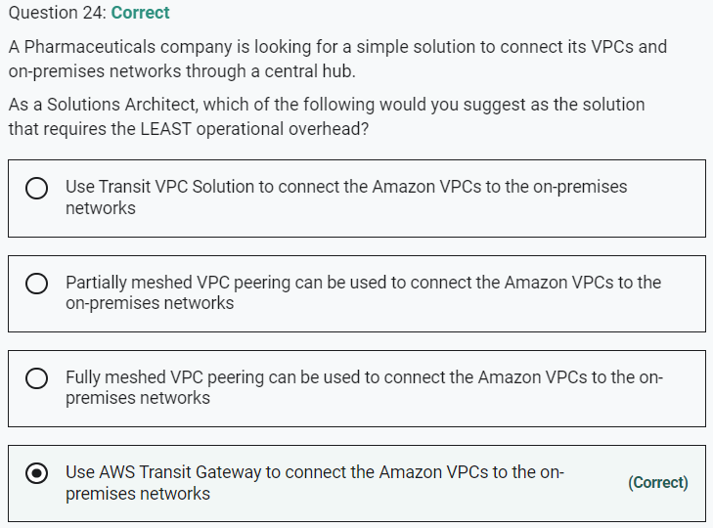

**Marked**

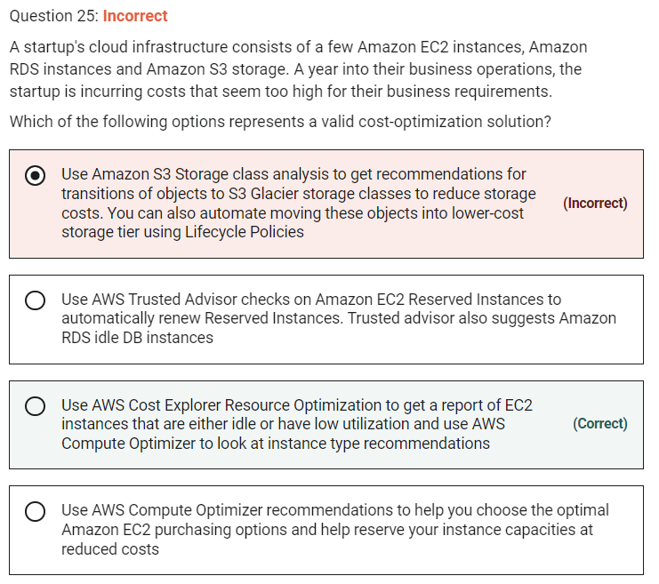

**Use AWS Cost Explorer Resource Optimization to get a report of EC2 instances that are either idle or have low utilization and use AWS Compute Optimizer to look at instance type recommendations** - AWS Cost Explorer helps you identify under-utilized EC2 instances that may be downsized on an instance by instance basis within the same instance family, and also understand the potential impact on your AWS bill by taking into account your Reserved Instances and Savings Plans.

AWS Compute Optimizer recommends optimal AWS Compute resources for your workloads to reduce costs and improve performance by using machine learning to analyze historical utilization metrics. Compute Optimizer helps you choose the optimal Amazon EC2 instance types, including those that are part of an Amazon EC2 Auto Scaling group, based on your utilization data.

**Use Amazon S3 Storage class analysis to get recommendations for transitions of objects to S3 Glacier storage classes to reduce storage costs. You can also automate moving these objects into lower-cost storage tier using Lifecycle Policies** -

By using Amazon S3 Analytics Storage Class analysis you can analyze storage access patterns to help you decide when to transition the right data to the right storage class. This new Amazon S3 analytics feature observes data access patterns to help you determine when to transition less frequently accessed STANDARD storage to the STANDARD_IA (IA, for infrequent access) storage class. Storage class analysis does not give recommendations for transitions to the ONEZONE_IA or S3 Glacier storage classes.

Marked

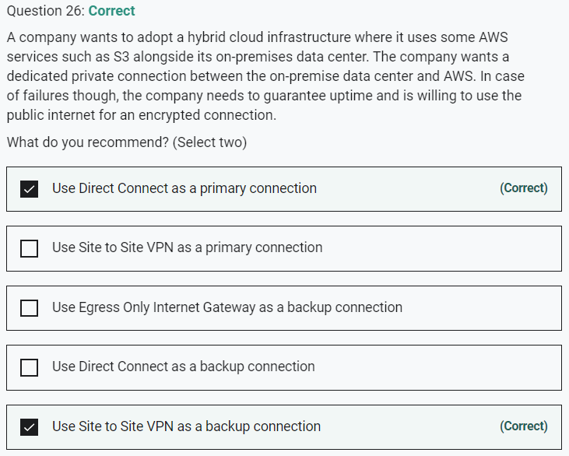

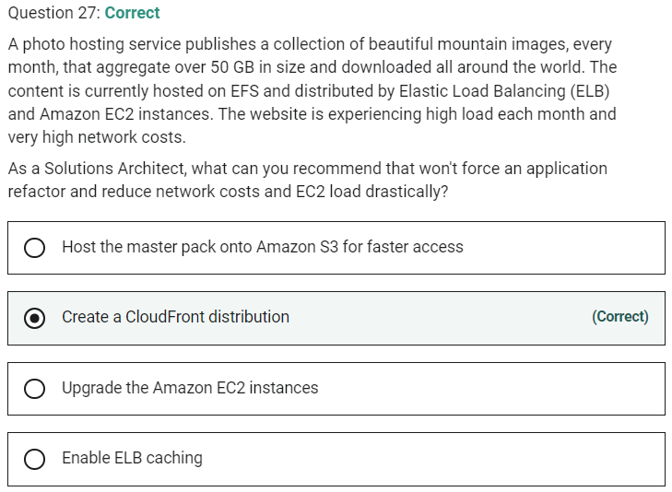

**Marked**

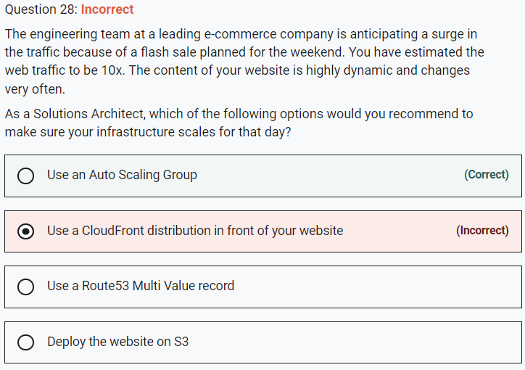

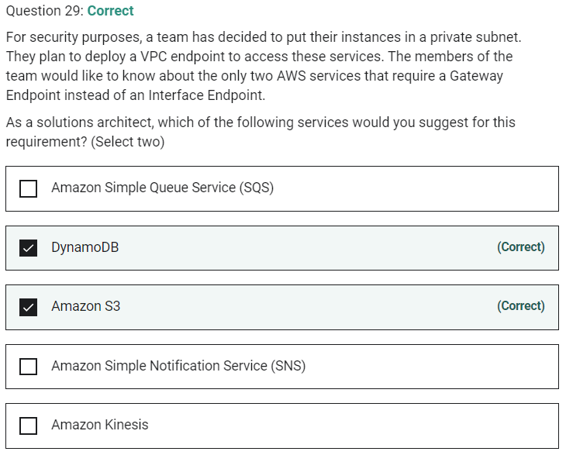

Marked

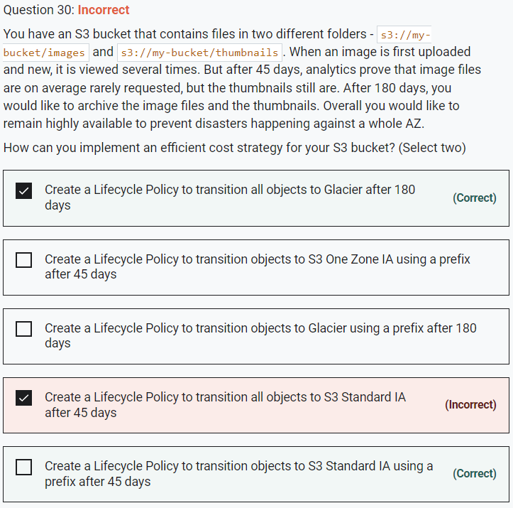

Marked

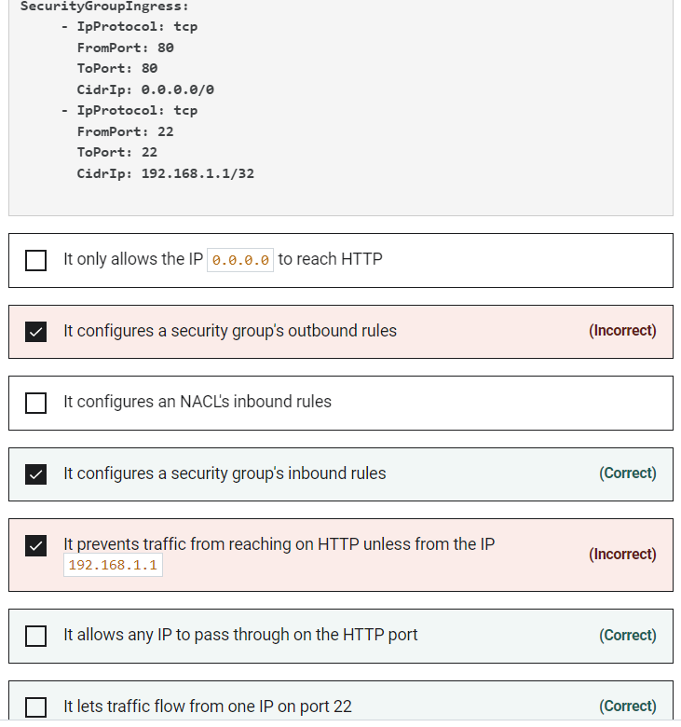

AWS CloudFormation provides a common language for you to model and provision AWS and third-party application resources in your cloud environment. AWS CloudFormation allows you to use programming languages or a simple text file to model and provision, in an automated and secure manner, all the resources needed for your applications across all regions and accounts. This gives you a single source of truth for your AWS and third-party resources.

Considering the given CloudFormation snippet, 0.0.0.0/0 means any IP, not the IP 0.0.0.0. Ingress means traffic going into your instance, and Security Groups are different from NACL. Each "-" in our security group rule represents a different rule (YAML syntax)

Therefore the CloudFormation snippet creates two Security Group inbound rules that allow any IP to pass through on the HTTP port and lets traffic flow from one source IP (192.168.1.1) on port 22.

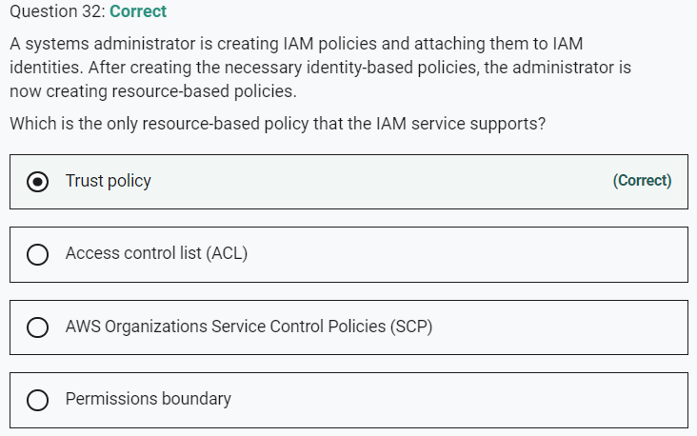

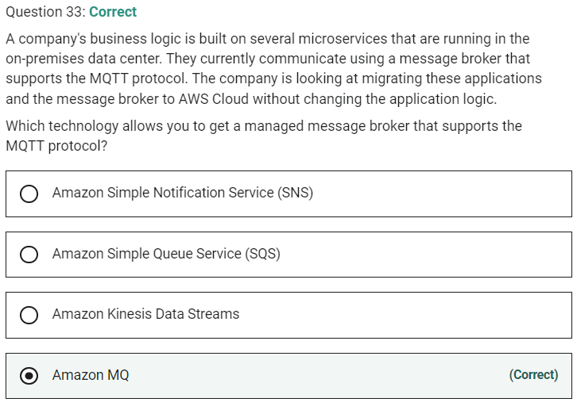

Marked

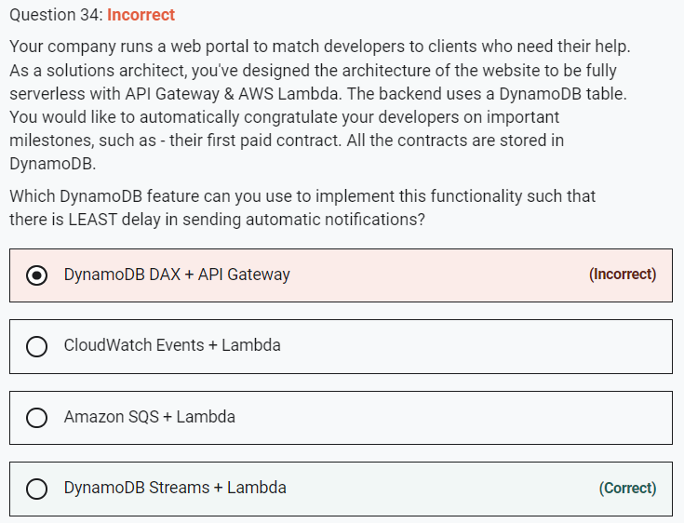

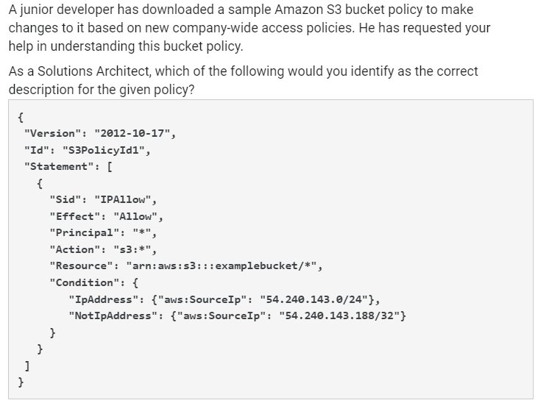

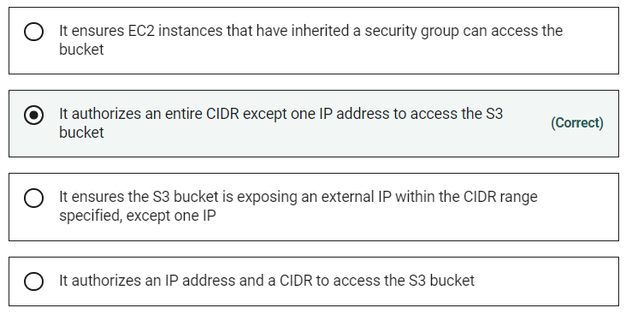

Marked

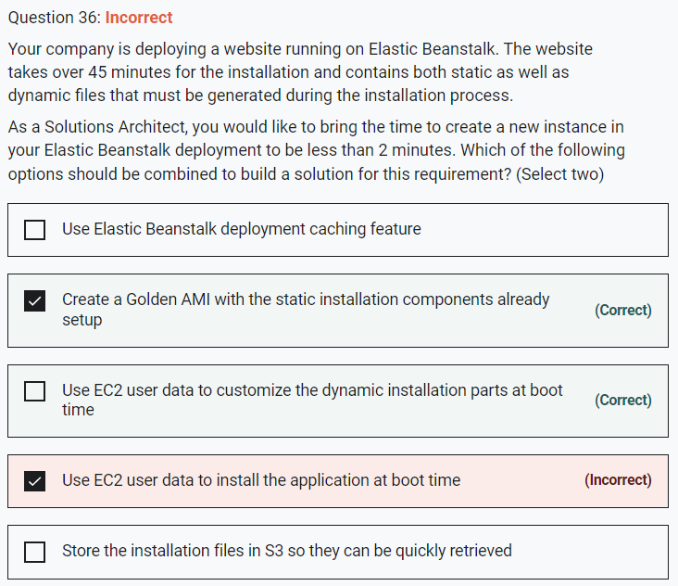

Marked

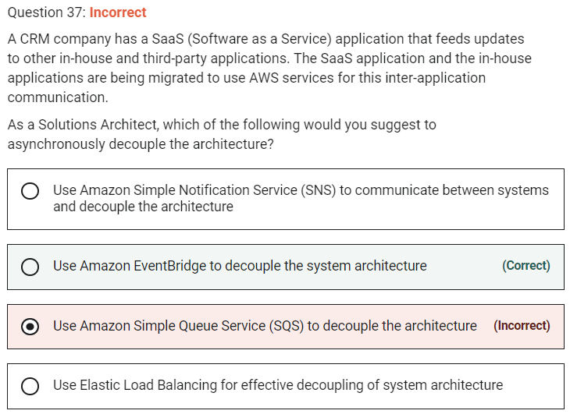

**Use Amazon EventBridge to decouple the system architecture** - Both Amazon EventBridge and Amazon SNS can be used to develop event-driven applications, but for this use case, EventBridge is the right fit.

Amazon EventBridge is recommended when you want to build an application that reacts to events from SaaS applications and/or AWS services. Amazon EventBridge is the only event-based service that integrates directly with third-party SaaS partners. Amazon EventBridge also automatically ingests events from over 90 AWS services without requiring developers to create any resources in their account

**Marked**

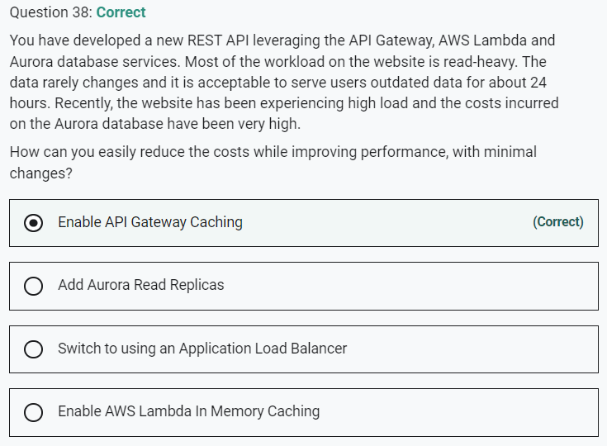

**Enable AWS Lambda In Memory Caching** - AWS Lambda has no native in-memory caching capability. Lambda is a serverless compute capacity. This option is incorrect and has been added as a distractor.

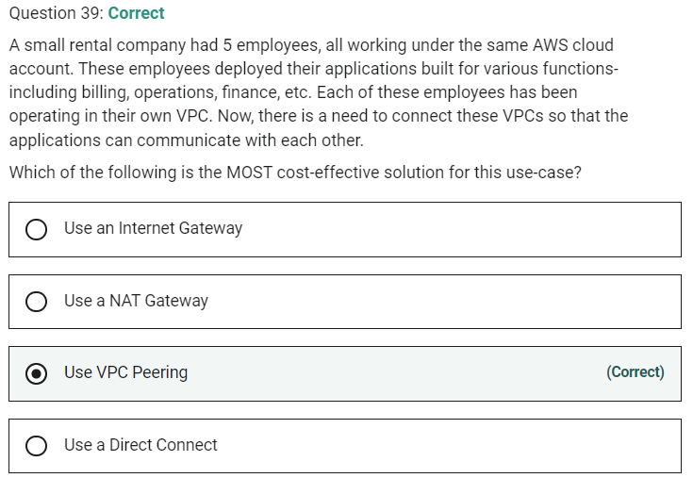

Marked

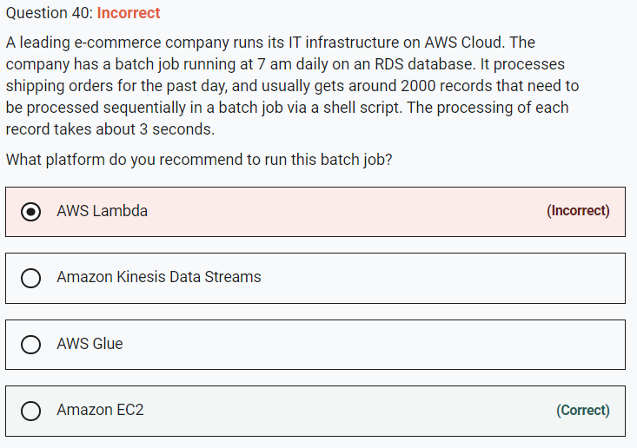

**AWS Lambda** - AWS Lambda lets you run code without provisioning or managing servers. AWS Lambda functions can be configured to run up to 15 minutes per execution. You can set the timeout to any value between 1 second and 15 minutes. The total runtime for the given use-case is 100 minutes (2000*3=6000 seconds = 100 minutes) but the Lambda would time out after 15 minutes, so this option is incorrect.

**Marked**

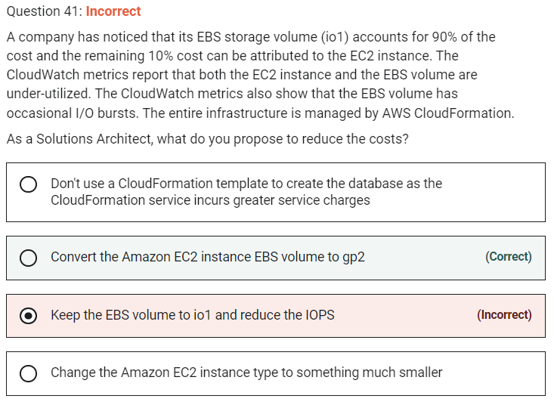

**Keep the EBS volume to io1 and reduce the IOPS** - Keeping the EBS volume to io1 and reducing the IOPS may interfere with the burst of performance we need, so this option is ruled out.

**Change the Amazon EC2 instance type to something much smaller** - Changing the EC2 instance type to something much smaller won't affect 90% of the costs that are incurred, therefore this option is also incorrect.

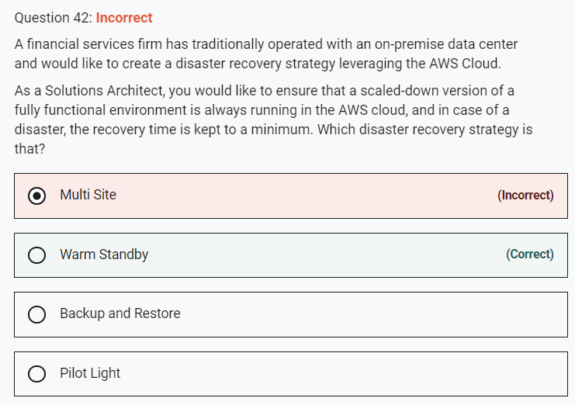

Marked

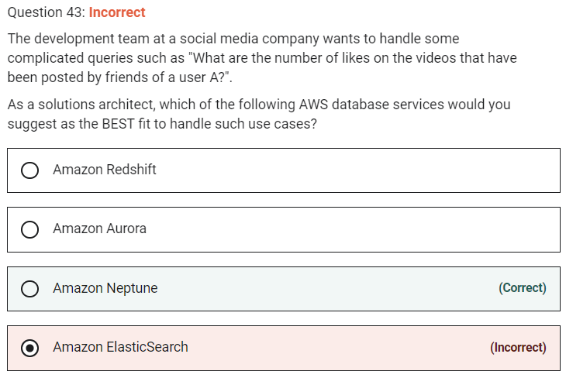

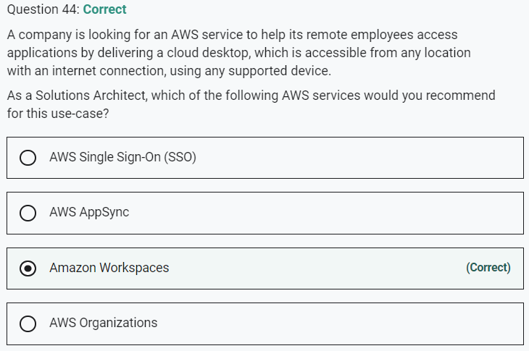

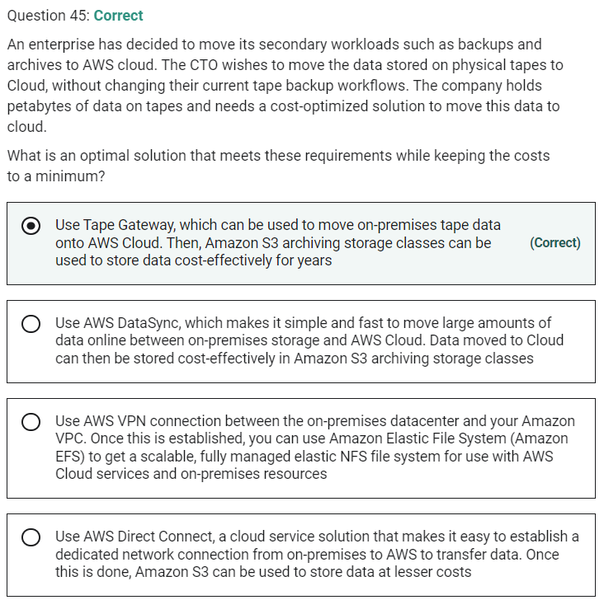

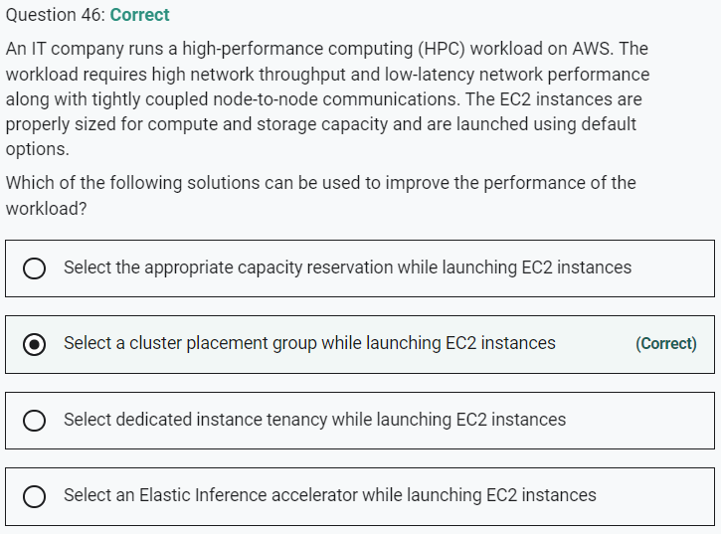

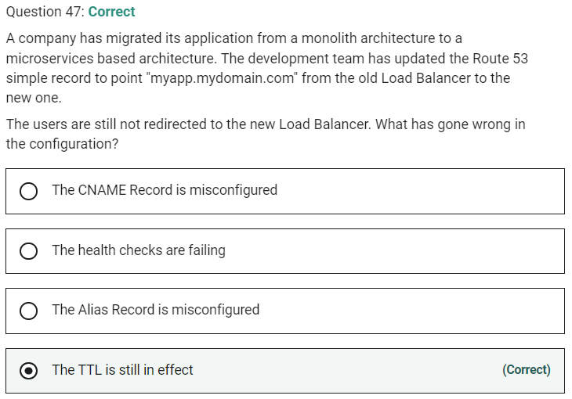

Marked

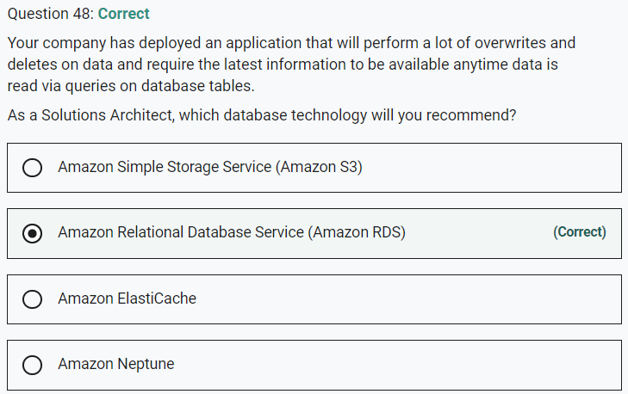

**Amazon Relational Database Service (Amazon RDS)** - Amazon Relational Database Service (Amazon RDS) makes it easy to set up, operate, and scale a relational database in the cloud. It provides cost-efficient and resizable capacity while automating time-consuming administration tasks such as hardware provisioning, database setup, patching, and backups. RDS allows you to create, read, update, and delete records without any item lock or ambiguity. All RDS transactions must be ACID compliant or be Atomic, Consistent, Isolated, and Durable to ensure data integrity.

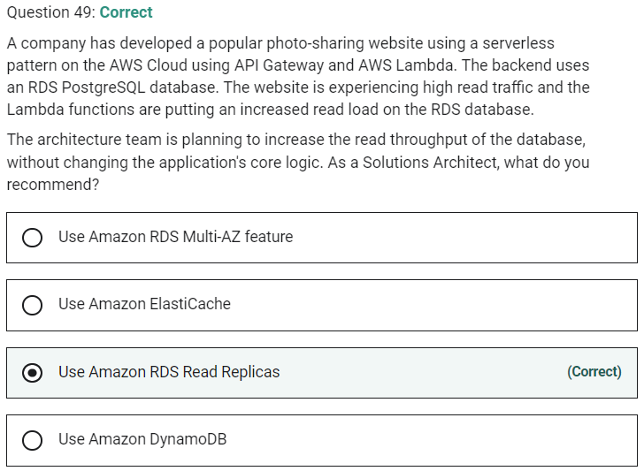

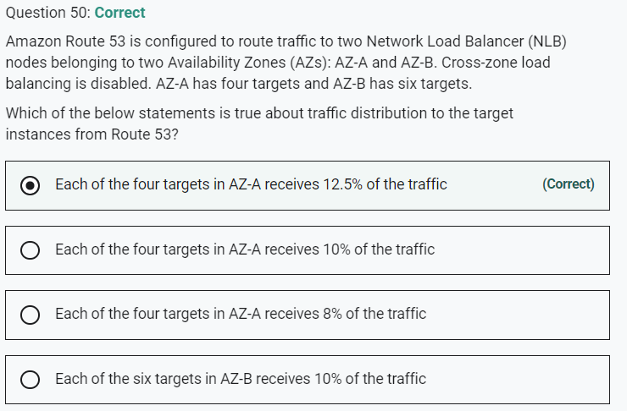

Marked

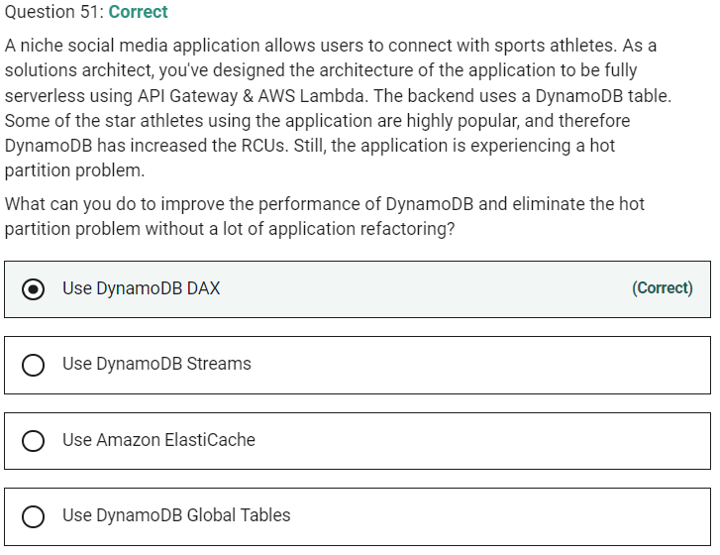

DAX solves hot key issues

DynamoDB Streams cannot address the hotkey issue.

DynamoDB Global Tables cannot address the hotkey issue.

Marked

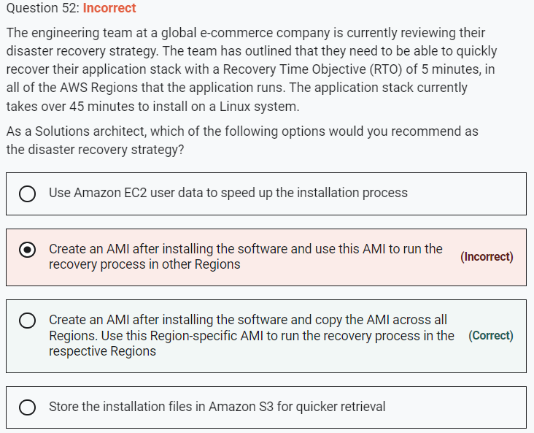

Marked

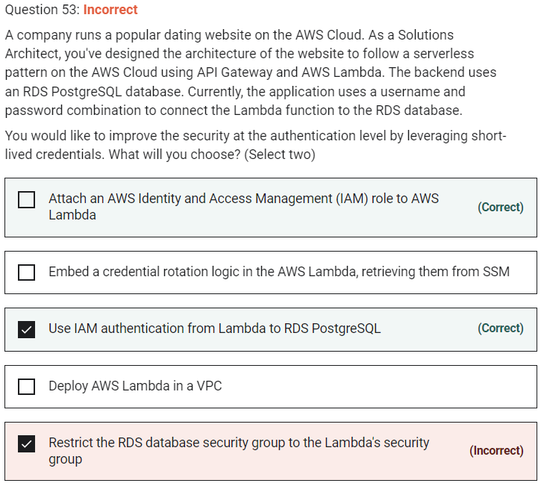

**Marked**

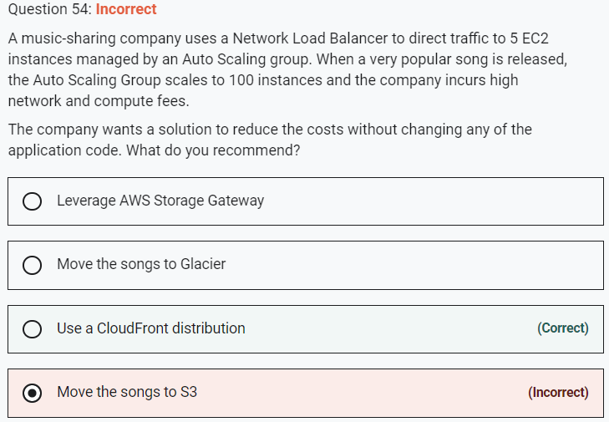

Marked

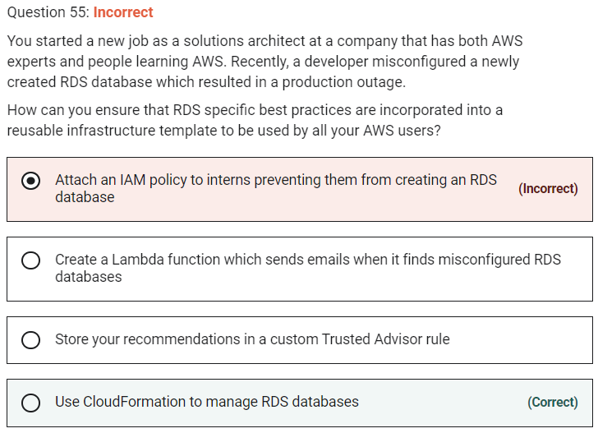

Marked

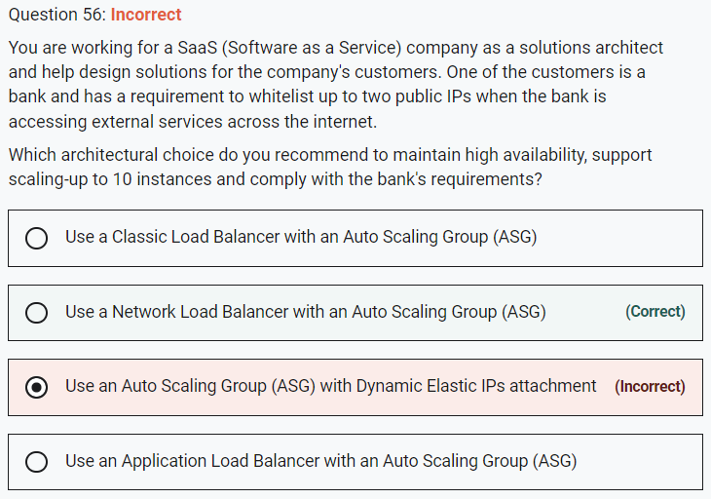

*\*Use a Network Load Balancer with an Auto Scaling Group (ASG) \** - Network Load Balancer is best suited for use-cases involving low latency and high throughput workloads that involve scaling to millions of requests per second.

Network Load Balancers expose a fixed IP to the public web, therefore allowing your application to be predictably reached using these IPs, while allowing you to scale your application behind the Network Load Balancer using an ASG.

**Use a Classic Load Balancer with an Auto Scaling Group (ASG)**

Application and Classic Load Balancers expose a fixed DNS (=URL) rather than the IP address. So these are incorrect options for the given use-case.

**Use an Auto Scaling Group (ASG) with Dynamic Elastic IPs attachment** - The option "Use an ASG with Dynamic Elastic IPs attachment" has been added as a distractor. ASG does not have a dynamic Elastic IPs attachment feature.

Marked

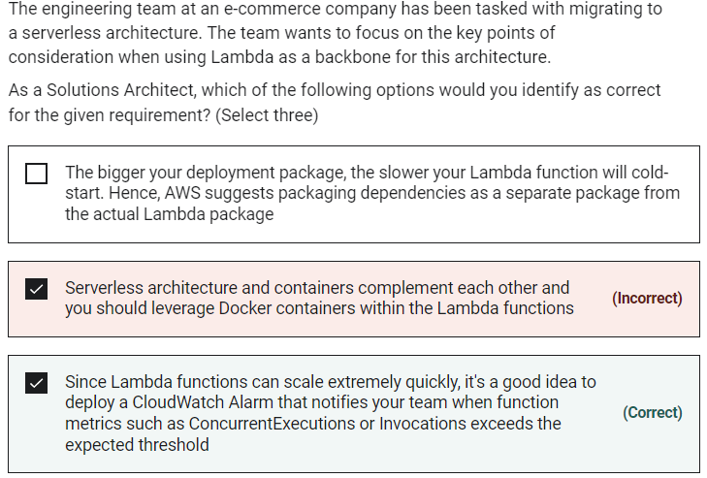

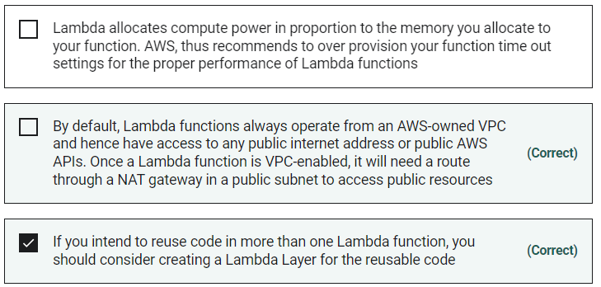

**Serverless architecture and containers complement each other and you should leverage Docker containers within the Lambda functions** - This statement is incorrect. AWS Lambda does not support running Docker containers.

Marked

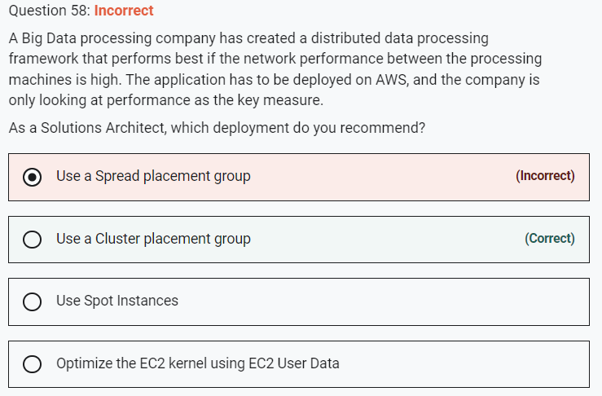

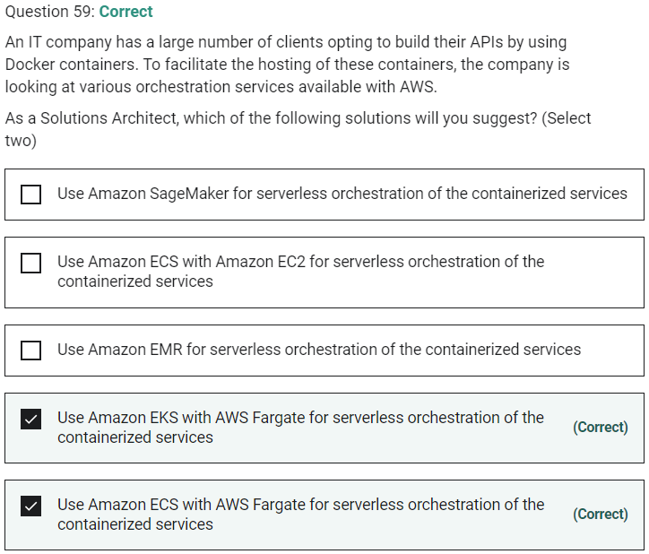

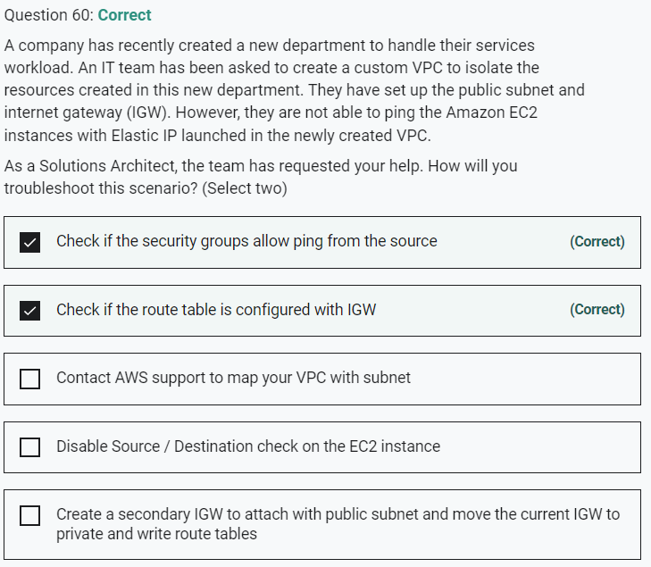

Marked

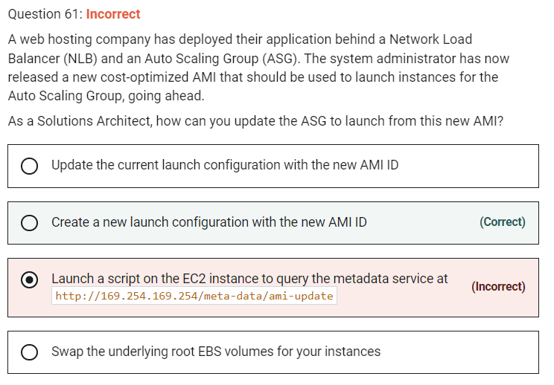

An Auto Scaling group is associated with one launch configuration at a time, and you can't modify a launch configuration after you've created it. To change the launch configuration for an Auto Scaling group, use an existing launch configuration as the basis for a new launch configuration. Then, update the Auto Scaling group to use the new launch configuration.

After you change the launch configuration for an Auto Scaling group, any new instances are launched using the new configuration options, but existing instances are not affected. To update the existing instances, terminate them so that they are replaced by your Auto Scaling group, or allow automatic scaling to gradually replace older instances with newer instances based on your termination policies.

**Update the current launch configuration with the new AMI ID** - Launch configurations are immutable meaning they cannot be updated. You have to create a new launch configuration, attach it to the ASG and then terminate old instances / launch new instances

**Swap the underlying root EBS volumes for your instances** - Root EBS volumes cannot be used to launch new instances, hence swapping the underlying root EBS volumes for your instances is an incorrect option. This has been added as a distractor.

**Launch a script on the EC2 instance to query the metadata service at http://169.254.169.254/meta-data/ami-update** - The metadata service cannot be used to launch new instances. Moreover, ami-update is not even a metadata item. This option has been added as a distractor.

